**2018-19 Cov Qib Kawm Ntawm Cov Tub Ntxhais Kawm Ntsuas Los Ntawm Kev Nyeem Ntawv thiab Ua Lej**

**Daim Ntawv Qhia: 0%, 20%, 40%, 60%, 80%, 100%**

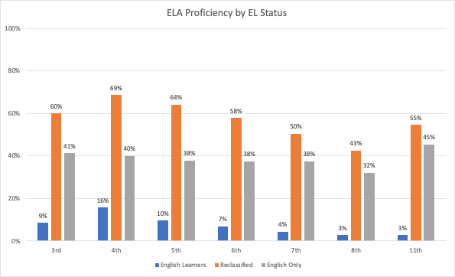

*Qhov Chaw Los: California Lub Chaw Ua Hauj Lwm Saib Xyuas Kev Kawm. (Lub ob hlis xyoo 2021). 2018-19 California Kev Tshuaj Ntsuam Xyuas Tub Ntxhais Kawm Ntawv Tau Thiab Kev Kawm Ua Tau Zoo.*

Tus Kawm Lus Askiv = Xiav

Muab Hloov Ua Lus Askiv Yam Npliag Plaws = Kab Ntxwv

Lus Askiv xwb = txho

**Paub Lus Askiv Zoo Los Ntawm Cov Lus Kawm**

|  |  |
| --- | --- |
| **3rd** | **9%, 60%, 41%** |
| **4th** | **16%, 69%, 40%** |
| **5th** | **10%, 64%, 38%** |
| **6th** | **7%, 58%, 38%** |
| **7th** | **4%, 50%, 38%** |
| **8th** | **3%, 43%, 32%** |
| **11th** | **3%, 55%, 45%** |

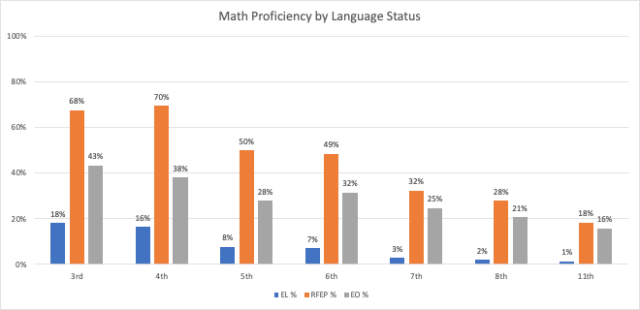

*Qhov Chaw Los: California Lub Chaw Ua Hauj Lwm Saib Xyuas Kev Kawm. (Lub ob hlis xyoo 2021). 2018-19 California Kev Tshuaj Ntsuam Xyuas Tub Ntxhais Kawm Ntawv Tau Thiab Kev Kawm Ua Tau Zoo.*

**Kev Ua Lej Tau Zoo Los Ntawm Cov Lus**

|  |  |
| --- | --- |
| **3rd** | **18%, 68%, 43%** |
| **4th** | **16%, 70%, 38%** |
| **5th** | **8%, 50%, 28%** |
| **6th** | **7%, 49%, 32%** |
| **7th** | **3%, 32%, 25%** |
| **8th** | **2%, 28%, 21%** |
| **11th** | **1%, 18%, 16%** |

**Coj Txoj Kev**

Thaum peb saib Lus Askiv (Enlish Language Arts) thiab ua lej tau zoo thoob plaws nroogFresno cov tsev kawm ntawv peb pom tias cov tub ntxhais kawm raug faib ua cov paub Lus Askiv npliag (RFEP) ua tau zoo dua lawv cov phooj ywg Askiv nkaus xwb nyob rau txhua qib kawm, qee zaum los ntawm ntau txog 30 feem pua.

Cov tub ntxhais kawm uas tsis tau muab faib qib kawm txuas ntxiv poob qis dua lawv cov qhab-nees ntawm qhov muab faib seem thiab tsuas-Askiv. Hauv cov qeb feem ntau, tsawg dua li 1 ntawm 10 ELs ua tau raws li ELA los sis kev ua lej.

**Vim li cas peb siv cov ntaub ntawv los ntawm xyoo 2018-19?**

Fresno cov tsev kawm ntawv qhib thawj zaug thaum lub Peb Hlis Ntuj xyoo 2020 teb raws li kev pom tus mob sib kis. Qhov kev txiav txim siab zam cov kev ntsuam xyuas hauv xeev tau ua tiav sai tom qab cov kev kaw no. Yog tsis muaj xyoo 2019-20 cov ntaub ntawv ntsuas hauv lub xeev, cov ntaub ntawv tam sim no tshaj plaws rau peb los ntawm lub xeev qhov kev tshuaj xyuas thaum xyoo 2018-19